Lathe Machine
Make SLBT Model SL-1552 Origin India

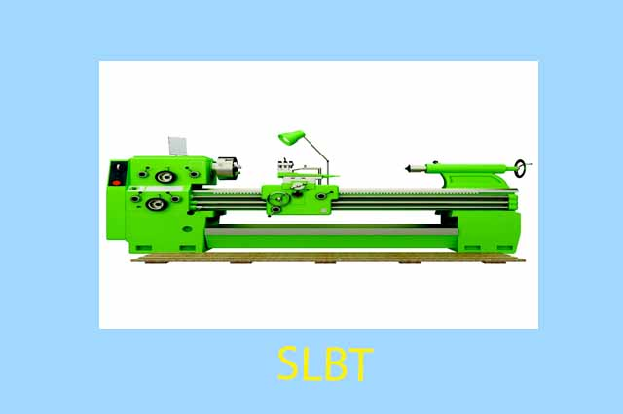

Technical Specifications
01). Automatic lathe machine Overall maximum dimensions of machine: Length Ã- width Ã- height = 2.3 Ã- 1.1257 Ã- 1.675; Maximum weight 3,000 Kg; Horizontal Spindle; Maximum work diameter 450mm;
02). Maximum distance between centers 710 mm; Maximum work length 710mm; Maximum pitch of thread 5 mm;
03). Speed range of cutter spindle: - 160 to 2500 rpm;
04). Speed range of work spindle 0.315 to 16 rpm;
05). Power of cutter head electric motor: 3 kW;
06). Power of work spindle electric motor: 1.5 kW.

